Exercise 1-4 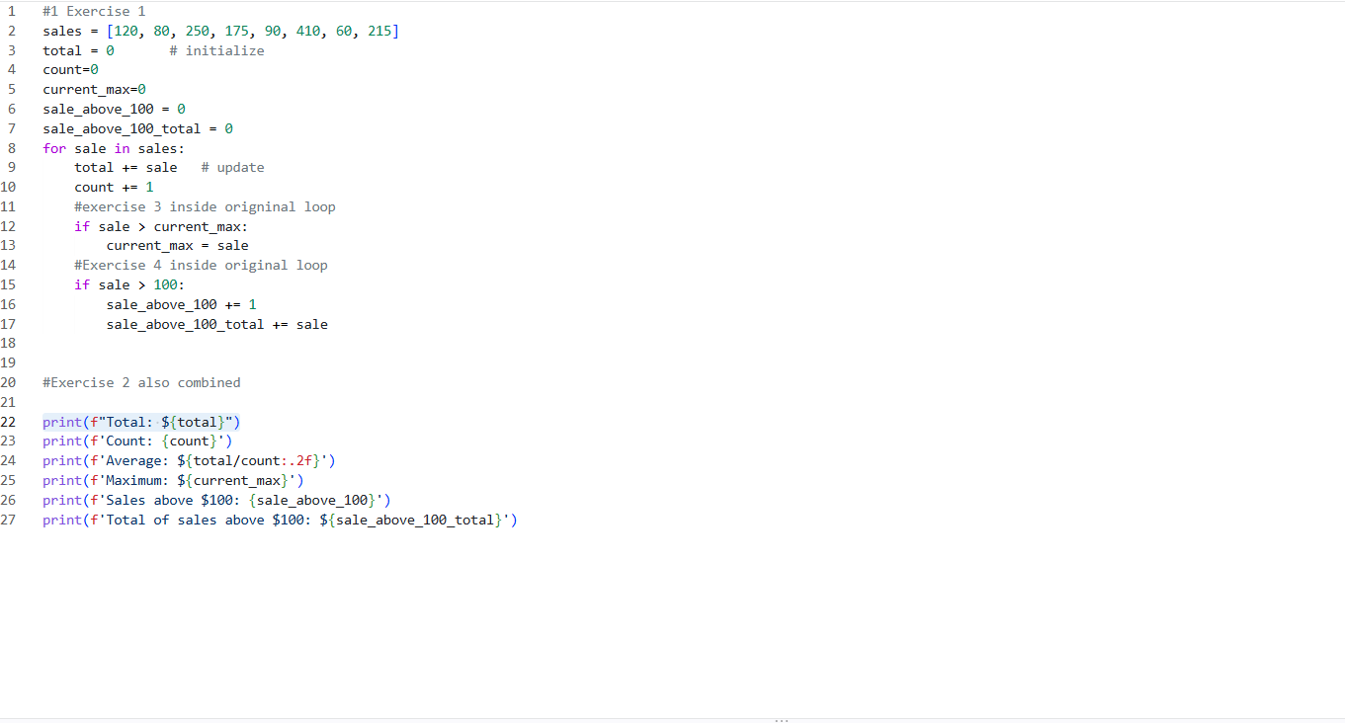

Exercise 5 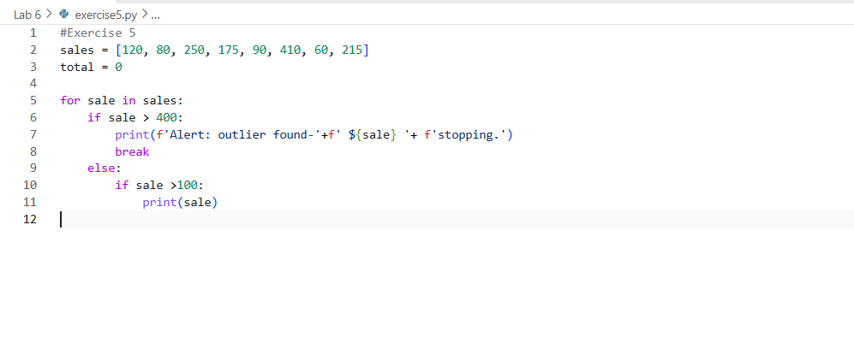

Exercise 6: 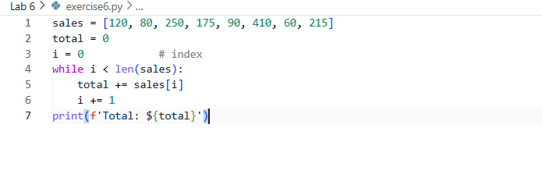
So when you know the exact number or limit where you want the while loop to run you would use while. For example if you want to run 10 instances while i>9
But if you don’t know like we do for sales than you would use for so it runs thru every instance

Exercise 7: 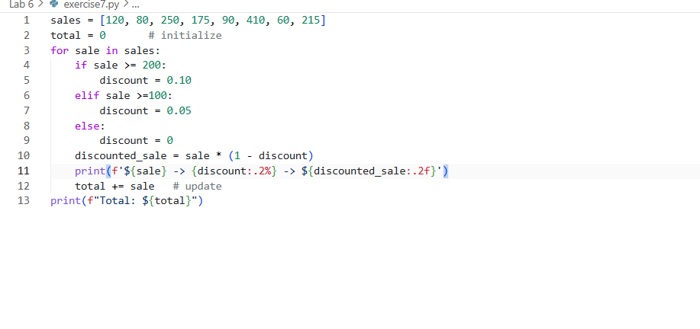

Reflection 1:
The 3 steps of the accumulator pattern is to first define it as = 0 you do this outside the for loop so when called within the for loop it has something to be called
Next you implement the for loop so it has something to run multiple times over
Finaly you add it to the defined value this can be done by using += which will add it to the total and be able to call it outside the for loop

2.) the while loop was much longer than the for loop since it needed to constantly run another check for I while the for loop just went thru all the variables. This is a pro when you want to do a set amount of variables as you can set how many but it’s a detriment since it does take longer

3.)A data set from my job would be sales at Chick Fil A, we would take all the sales that we earned but also the amount of orders. Adding all the sales up and than total cars that came thru than dividing total by cars so we could have our total sales. Total orders and sales per order.

